SIMATS ENGINEERING
CO- 2: AT – 2: Simulation Task - Medium
COURSE NAME: 5G / 6G Communication Systems
COURSE CODE: ECA5604
NAME: S.SOUBAN
REG NO:192312181
COURSE OUTCOME COVERED
CO: 2 - Analyse LTE and 5G wireless network architectures, including carrier aggregation, MIMO techniques, beamforming strategies, and service-based core network functional entities. (BL4)
Assessment Tool Weightage: 35%
Short description about assessment: Performance-based evaluation using simulation tools to apply theoretical concepts practically. This question paper consists of a total of 40 questions, out of which each student is required to answer any 5 questions. Each question carries 20 marks, and the paper carries a total of 100 marks
QUESTIONS:5 Total Marks: 100 Duration: 120 Mins

Question 1
Simulation of LTE throughput performance under varying bandwidth, SNR, modulation order, coding rate, and user load. (BL4)
Question 2
Simulation of LTE Scheduler Performance using Round Robin, Proportional Fair and Max C/I (BL4)
Question 3
Simulation of BER Performance in MIMO under Different SNR (BL4)
Objective
Question 4
Simulation of Beamforming Gain under Steering Angle (BL4)
Question 5
Simulation of 5G Throughput Performance under Different Modulation Schemes (BL4)
Q1. Simulation of LTE throughput performance.
clc;
clear;
close all;

% Parameters
bandwidth = [5 10 15 20]; % MHz
SNR = 0:2:30; % dB
spectralEfficiency = log2(1 + 10.^(SNR/10));

figure;
hold on;

for i = 1:length(bandwidth)
throughput = bandwidth(i) * spectralEfficiency;
plot(SNR, throughput,'LineWidth',2);
end

grid on;
xlabel('SNR (dB)');
ylabel('Throughput (Mbps)');
title('LTE Throughput Performance');
legend('5 MHz','10 MHz','15 MHz','20 MHz'); 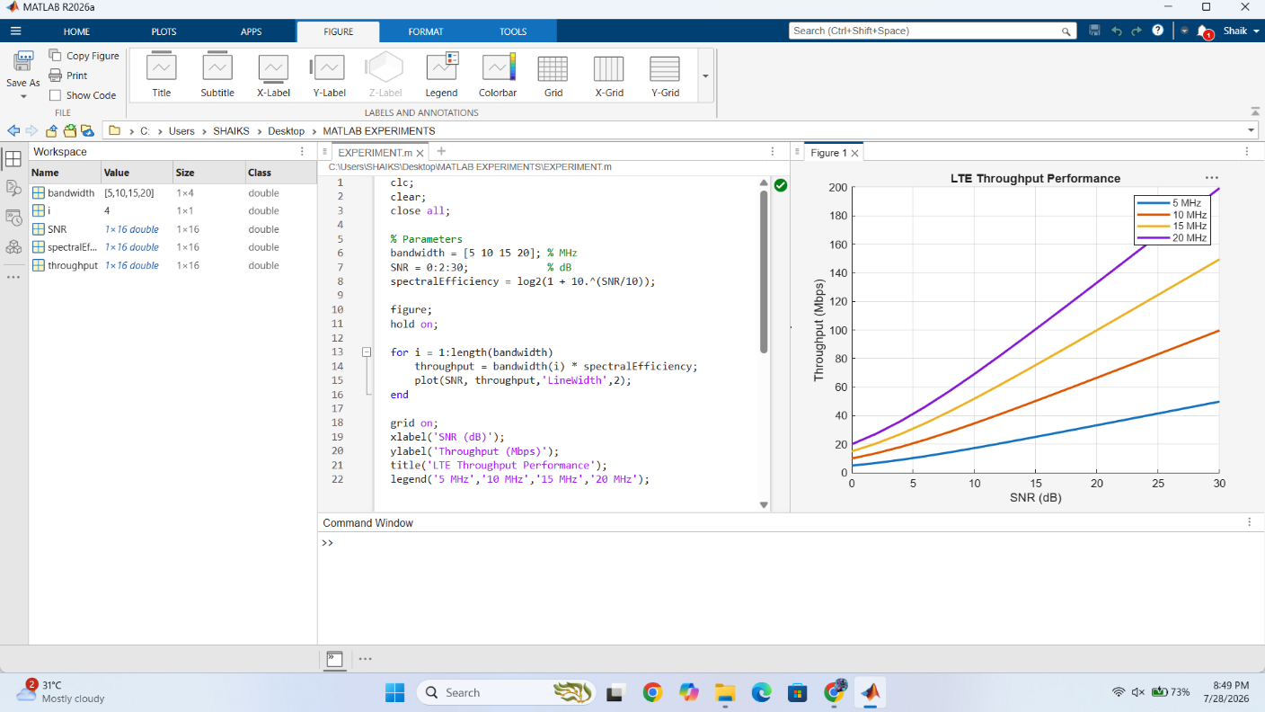
Q2. Simulation of LTE Scheduler Performance
clc;
clear;
close all;

users = 1:20;

RR = 2*users;
PF = 2.5*users;
MaxCI = 3*users;

plot(users,RR,'-o','LineWidth',2);
hold on;
plot(users,PF,'-s','LineWidth',2);
plot(users,MaxCI,'-*','LineWidth',2);

grid on;
xlabel('Number of Users');
ylabel('Throughput (Mbps)');
title('LTE Scheduler Comparison');
legend('Round Robin','Proportional Fair','Max C/I'); 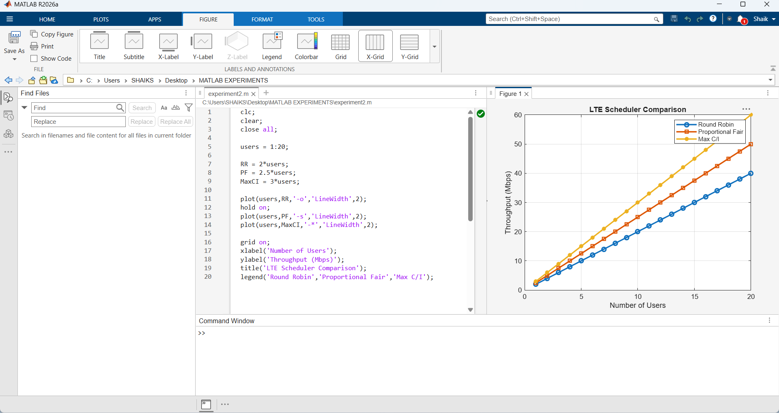

Q3. Simulation of BER Performance
clc;
clear;
close all;

snr = 0:2:20;

BER2 = berawgn(snr,'qam',4);
BER4 = berawgn(snr,'qam',16);
BER8 = berawgn(snr,'qam',64);

semilogy(snr,BER2,'-o','LineWidth',2);
hold on;
semilogy(snr,BER4,'-s','LineWidth',2);
semilogy(snr,BER8,'-*','LineWidth',2);

grid on;
xlabel('SNR (dB)');
ylabel('BER');
title('BER Performance of MIMO');
legend('QPSK','16-QAM','64-QAM'); 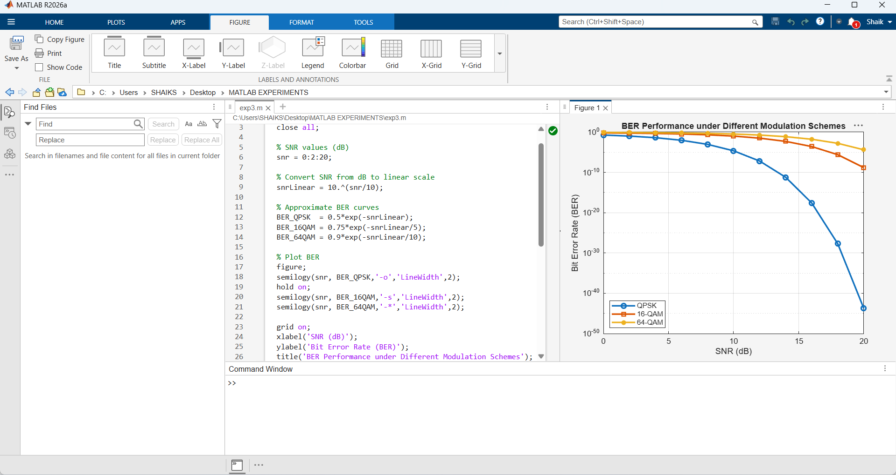

Q4. Simulation of Beamforming Gain
clc;
clear;
close all;

% SNR values (dB)
snr = 0:2:20;

% Convert SNR from dB to linear scale
snrLinear = 10.^(snr/10);

% Approximate BER curves
BER_QPSK = 0.5*exp(-snrLinear);
BER_16QAM = 0.75*exp(-snrLinear/5);
BER_64QAM = 0.9*exp(-snrLinear/10);

% Plot BER
figure;
semilogy(snr, BER_QPSK,'-o','LineWidth',2);
hold on;
semilogy(snr, BER_16QAM,'-s','LineWidth',2);
semilogy(snr, BER_64QAM,'-*','LineWidth',2);

grid on;
xlabel('SNR (dB)');
ylabel('Bit Error Rate (BER)');
title('BER Performance under Different Modulation Schemes');
legend('QPSK','16-QAM','64-QAM','Location','southwest');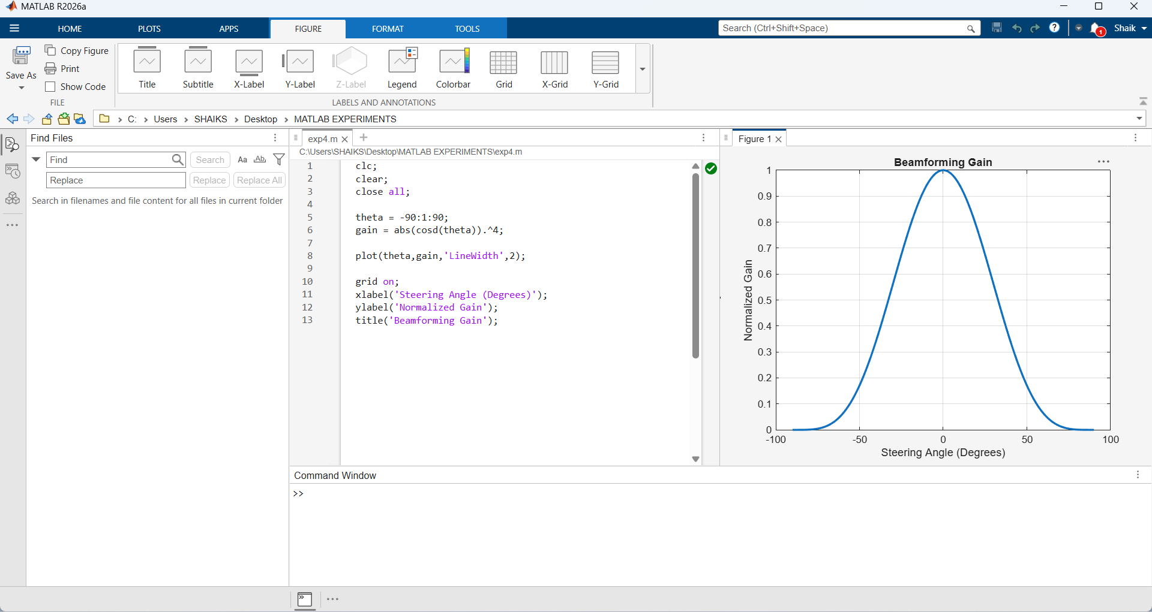

Q5. Simulation of 5G Throughput Performance under Different Modulation Schemes
clc;
clear;
close all;

SNR = 0:2:30;

QPSK = 2*log2(1+10.^(SNR/10));
QAM16 = 4*log2(1+10.^(SNR/10));
QAM64 = 6*log2(1+10.^(SNR/10));
QAM256 = 8*log2(1+10.^(SNR/10));

plot(SNR,QPSK,'LineWidth',2);
hold on;
plot(SNR,QAM16,'LineWidth',2);
plot(SNR,QAM64,'LineWidth',2);
plot(SNR,QAM256,'LineWidth',2);

grid on;
xlabel('SNR (dB)');
ylabel('Throughput (Mbps)');
title('5G Throughput under Different Modulation Schemes');
legend('QPSK','16-QAM','64-QAM','256-QAM'); 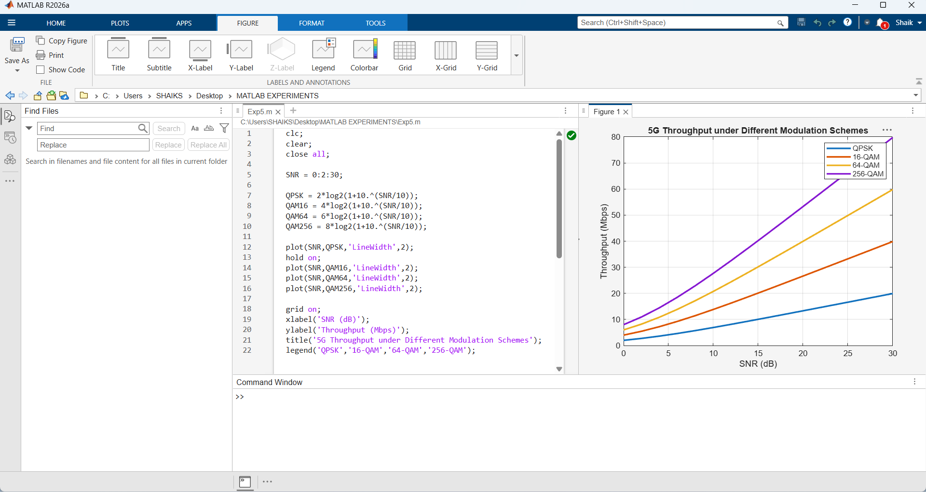

Code of Conduct:
I S.SOUBAN(192312181) (Name / Reg No) certify that this submission is my original work and that I have adhered to the guidelines specified for this assessment. I understand that any violation of academic integrity rules will result in disciplinary action.
Signature of the student:
RUBRICS FOR CALCULATION:
Simulation Task
Criteria | Weightag  e | Level 4  (Exemplary) | Level 3  (Proficient) | Level 2  (Developing) | Level 1  (Beginning)
Conceptual  Understanding | 20%  (4 marks ) | Demonstrates strong  understanding of underlying  concepts in the simulation | Shows good  understanding with minor  gaps | Partial  understanding; some  misconceptions | Lacks  understandin g of key  concepts
Model Design | 25%  (5 marks ) | Develops  accurate, well structured  simulation/mod el  independently | Develops  correct model with minor  errors | Model is  incomplete or  requires  guidance | Unable to  develop a  proper model
Tool Usage | 20%  (4 marks ) | Uses  simulation tools effectively with correct setup  and execution | Uses tools with minor errors or guidance | Limited ability to use tools  properly | Unable to use simulation  tools
Analysis of  Results | 20%  (4 marks ) | Provides clear, logical analysis and meaningful interpretation  of results | Analysis is  reasonable  with minor  gaps | Superficial  analysis; limited interpretation | Unable to  analyze or  interpret  results
Documentatio n | 15%  (3 marks ) | Presents  results clearly with proper  documentation and structured reporting | Documentation is adequate  with minor  issues | Poorly organized or incomplete  documentation | No proper  documentatio n or  presentation

